1. In order to run the automatic tests, “Appium” and “Eclipse” need to be installed on server.

**Eclipse** :Free IDE. It is an open source development platform based on Java. [http://www.eclipse.org](http://www.eclipse.org/)

**Appium**: It is an open source test automation tool to drive iOS, Android, and Windows apps runs automatically on the device. <https://github.com/appium/appium>

1. Run the automatic test
   1. Start up Appium.

Configure server IP address and port, start the Server and connect server to mobile phone. (The mobile need to open the debug port)

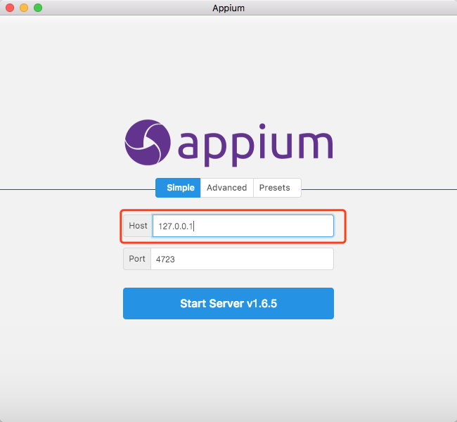

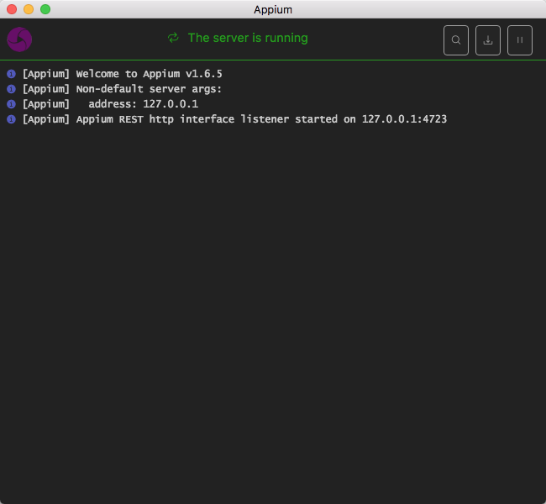

* 1. Start up the Eclipse, go to File then Import and select Existing Maven Projects(the developed automatic test script) .

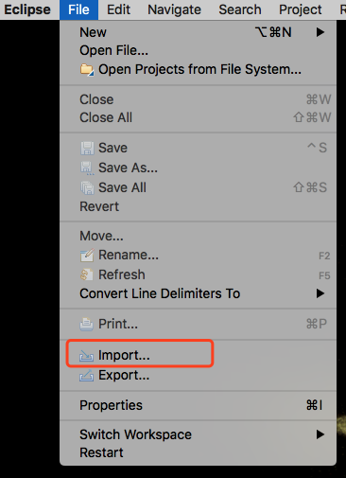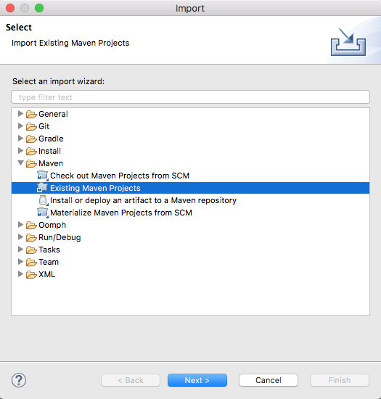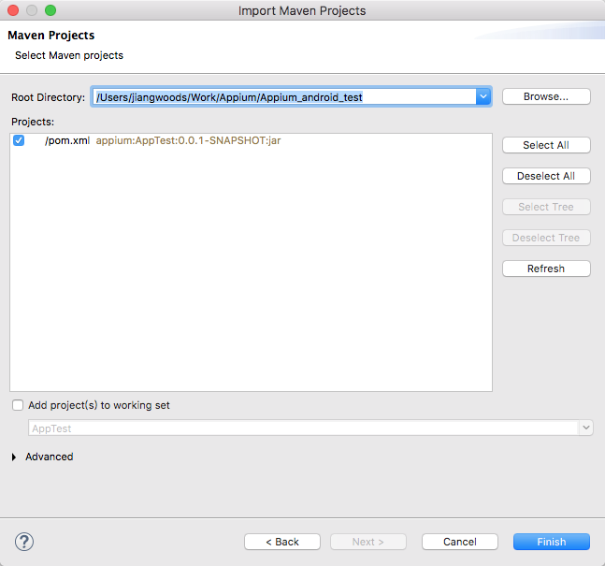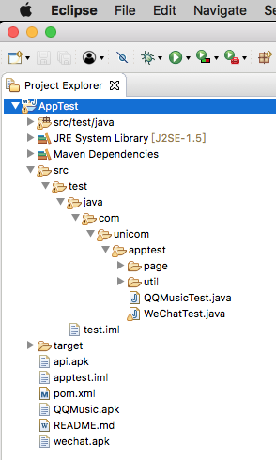

* 1. Compile and run the Eclipse automatic test scrip. The smartphone will be controlled by the server to install, open, uninstall two specified APK: QQ and Wechat automatically.

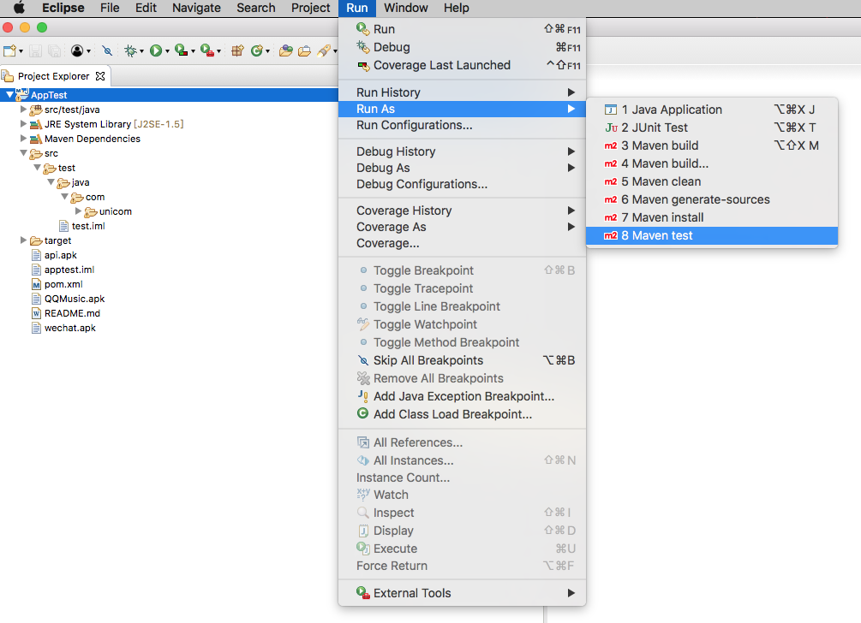

The device will be controlled to carry out the automatic test, on the server we can check the test log :

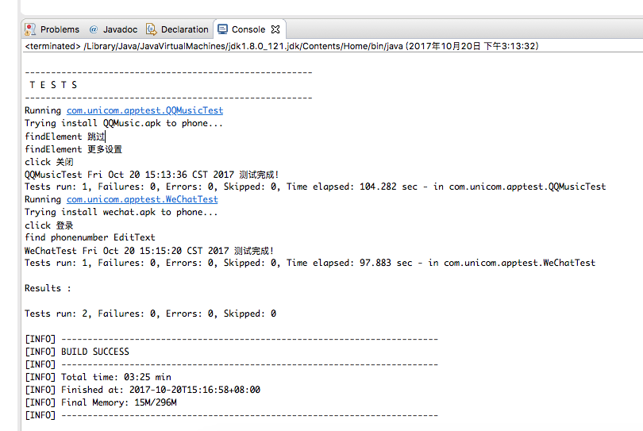

*（The COMMAND :*

*To compile and run all tests, run:*

*mvn clean test*

*To run a single test, run:*

*mvn -Dtest=com.unicom.apptest.QQMusicTest test）*